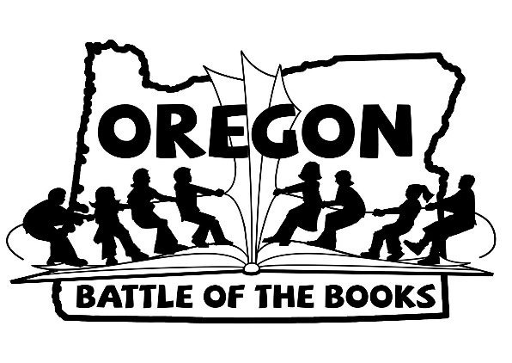
OBOB Team Registration
Please turn your team’s registration form and permission slips from each team member in to the basket in the library by October 31st.

Team Name (please limit to 4 words): _______________________________________________________

Parent Helper: _____________________________Email Address: ________________________________
*Parent Helpers are not required, but it is very helpful if the team has a parent to help them get organized.
□ Please check here if you need help finding a team.

Team Member Information
 | First Name | Last Name | Teacher
Member #1

Member #2

Member #3

Member #4

If you have questions, please email Lisa Hedberg and Julie Atwood at wpsobob@gmail.com.

