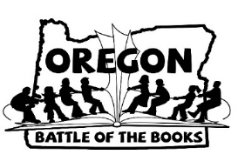
OBOB Parent Permission Form

Please return this permission slip with your team registration in to the basket in the library by October 31st.
Student’s name: _________________________________________

Student’s Teacher/Grade: _________________________________

Team Name: ___________________________________________
□ I have read the attached OBOB book synopses (which can also be found on the OBOB page of the Willamette PTA website) and give my child permission to participate in the program for the 2018-2019 school year.
Parent Name: _________________________________________(print)
__________________________________ (signature)

Parent Email: ____________________________________________

